**The Holy Way Presbyterian Church**

**Tucson, Arizona**

**August 15, 2021 9:30 a.m.**

**Living In Community...**

**Words of Meditation -** In the beginning God created humanity, to live with one another and to love each other too.  Not to be subjugated by another, but to live with mutual respect, love and submission to each other in the household. Let us discover the second half of Ephesians 5 together.

**Welcome to Worship** Rev. Tina Salvaneschi

**Opening Prayer**

**Release Children to Sunday School - Miss Kathy**   

**Introit:** *Eternal Father, Strong to Save (Hymn #8, V4)*

Ryan Phillips, Choir Director

**Hymn:** *Oh Christ, the Great Foundation* (Hymn #361) Ryan Phillips, Choir Director

**Call to Worship:**   Lay Leader, Joan Valenzuela

John 13:34-35 A New Commandment I give to you, that you love one another; as I have loved you, that you also love one another. By this all will know that you are My disciples, if you have love for one another.”

**People: Amen**

**Birthdays and Anniversaries** Alfonso Valenzuela

**Celebrations, Joys and Concerns** Rev. Tina Salvaneschi

The People of the Congregation Share

**...The Lord’s Prayer**

**People:**  Our Father, who art in heaven, hallowed be thy name.  Thy kingdom come, thy will be done on earth as it is in heaven.  Give us this day our daily bread, and forgive us our debts as we forgive our debtors.  And lead us not into temptation, but deliver us from evil, for thine is the kingdom and the power and the glory forever.  Amen

**Anthem:** *Be Joyful* The Chancel Choir

**Tithes and Offering:  Prayer** Rev. Tina Salvaneschi

    (option: Place you index card with a private prayer for Pastor)

(option: write on index card a word or two what giving to God means to you and place index cards in plate)

**Offertory Music:**  Dr. Astrid Chan

*(offering baskets available at all four exits as you leave)*

**Scripture Reading:** Lay Leader, Joan Valenzuela

**Ephesians 5:22-33**

22 Wives, submit to your own husbands, as to the Lord. 23 For the husband is head of the wife, as also Christ is head of the church; and He is the Savior of the body. 24 Therefore, just as the church is subject to Christ, so let the wives be to their own husbands in everything.

25 Husbands, love your wives, just as Christ also loved the church and gave Himself for her, 26 that He might sanctify and cleanse her with the washing of water by the word, 27 that He might present her to Himself a glorious church, not having spot or wrinkle or any such thing, but that she should be holy and without blemish. 28 So husbands ought to love their own wives as their own bodies; he who loves his wife loves himself.

29 For no one ever hated his own flesh, but nourishes and cherishes it, just as the Lord does the church. 30 For we are members of His body, of His flesh and of His bones. 31 “For this reason a man shall leave his father and mother and be joined to his wife, and the two shall become one flesh.” 32 This is a great mystery, but I speak concerning Christ and the church. 33 Nevertheless let each one of you in particular so love his own wife as himself, and let the wife see that she respects her husband.

Leader:  This is the Word of the Lord.     **People:  Thanks be to God.**

**Message:**  *“The Christian Household”*  Rev. Tina Salvaneschi

**Sending Hymn:** *Alleluiah, Laud and Blessing! (Hymn 755)*

Ryan Phillips, Choir Director

**Children Return from Sunday School!** Miss Kathy

**Benediction:**  2 Corinthians 13:14 Rev. Tina Salvaneschi

**Song:** *Let There Be Peace On Earth* Ryan Phillips, Choir Director

**Postlude:** Dr. Astrid Chan

**Stay Connected at The Holy Way**

***“Sermon Debrief Bible Study in person on Campus and Zoom”*** - Tuesday 10:00 a.m.

It’s Both! Come and meet live in the Conference Room at 10:00 a.m. or join on Zoom and we will conference you in on the big screen!

This is a great way to get to Fellowship, wrestle with questions about Sunday’s sermon, ponder the meaning of God’s Word, and discover how Scriptures can transform our lives today. This is led by Pastor Tina and is interactive! Come join the live class if you are able!

***“Thoughtful Thursdays”*** - Thursday 10:00 a.m. Zoom

This is a great way to stay connected (especially for our snowbirds, and folks that can’t make it to in-person services!). We share about our lives, spend time talking, share joys, prayer requests…and anything else that comes up. Oh yes, laughter seems to happen too. This is group led, with Pastor Tina and for women AND men!

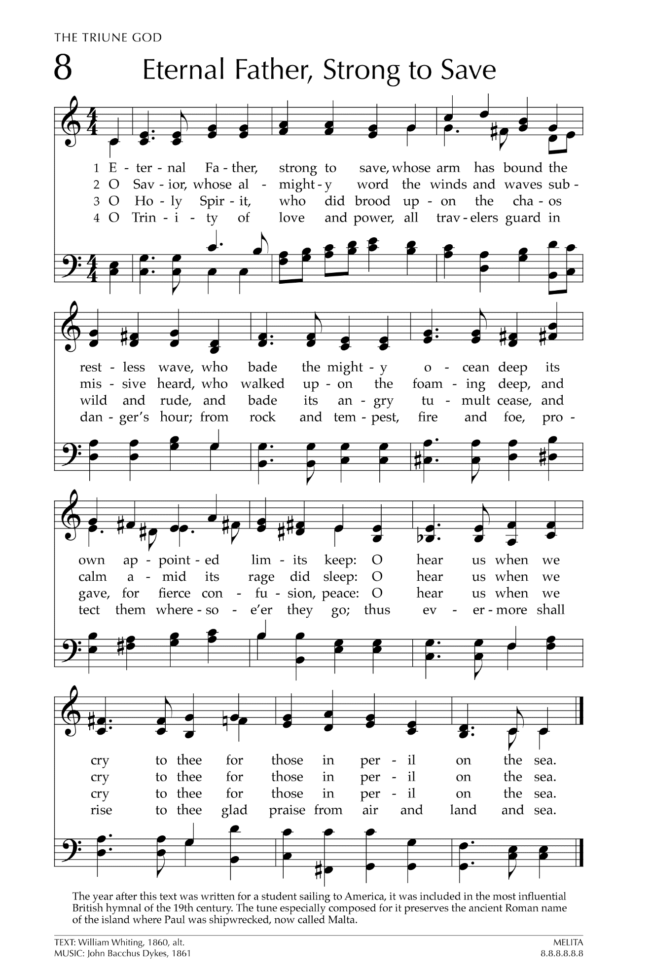

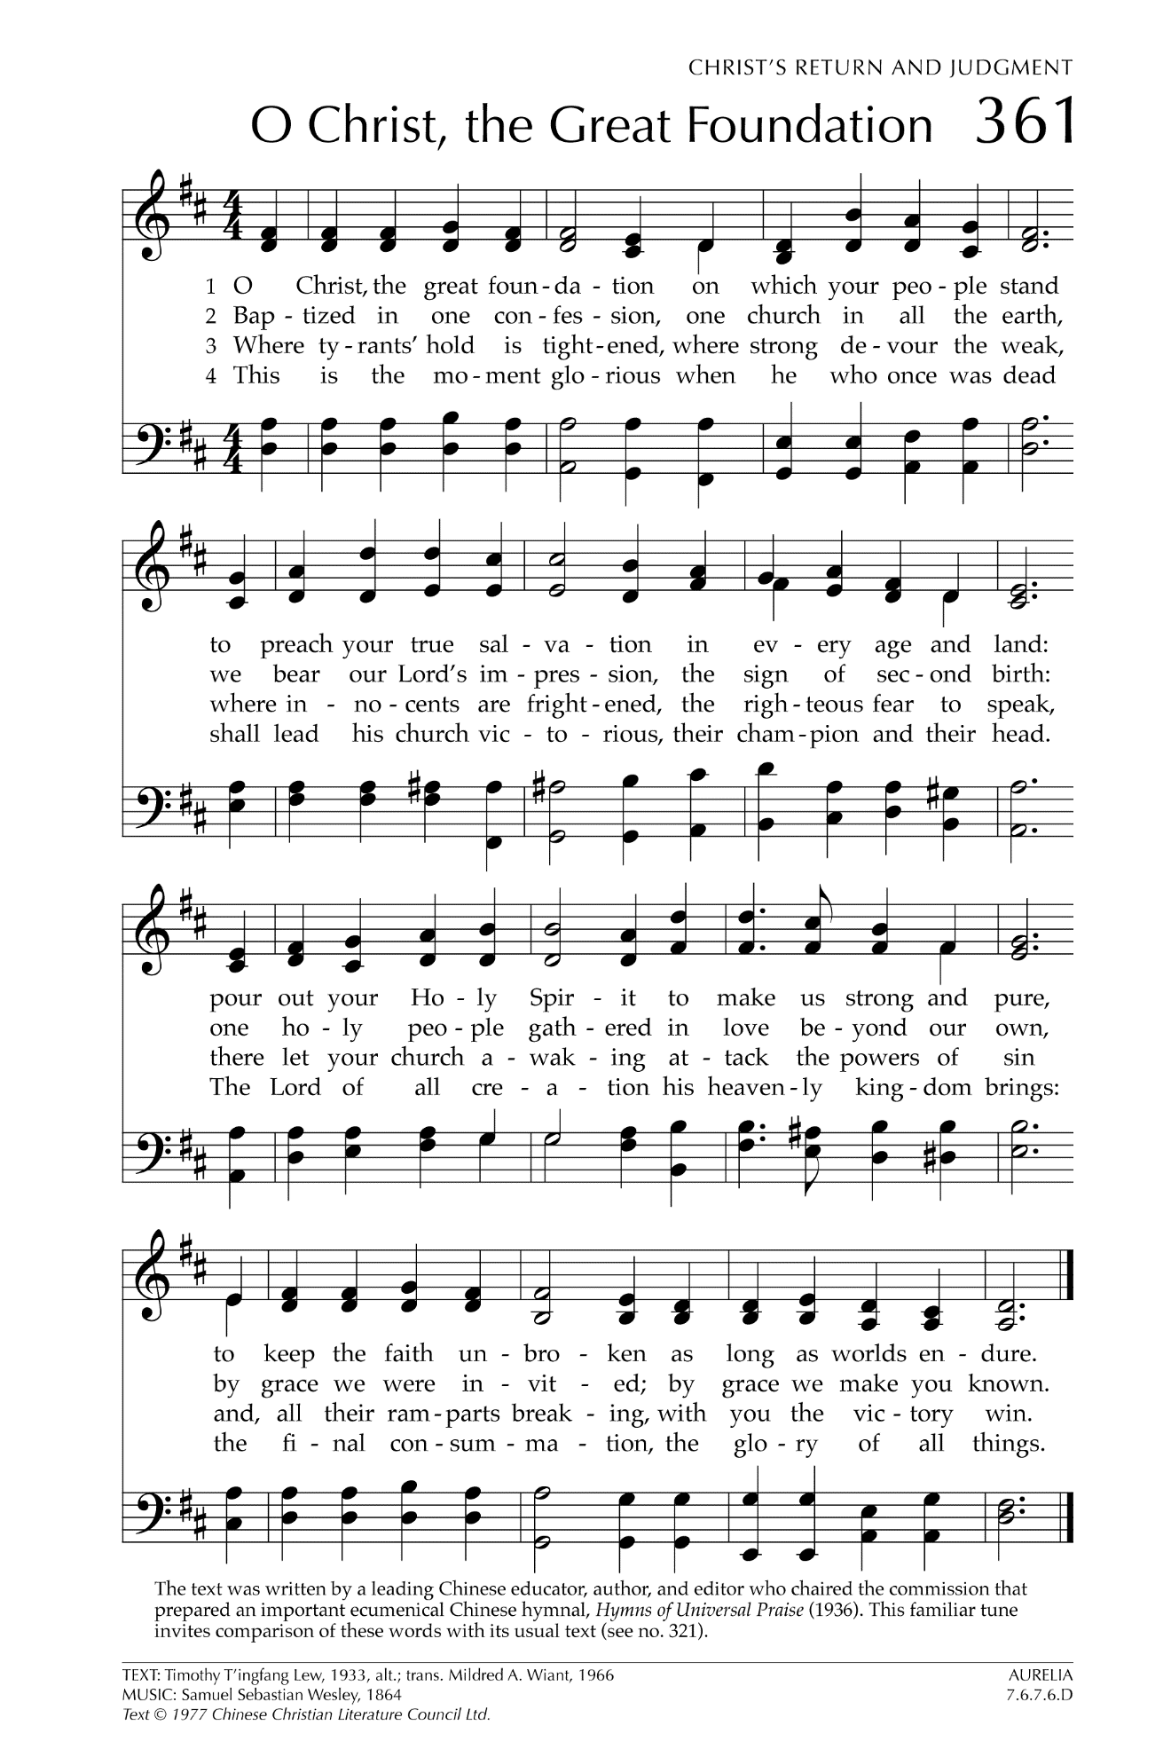

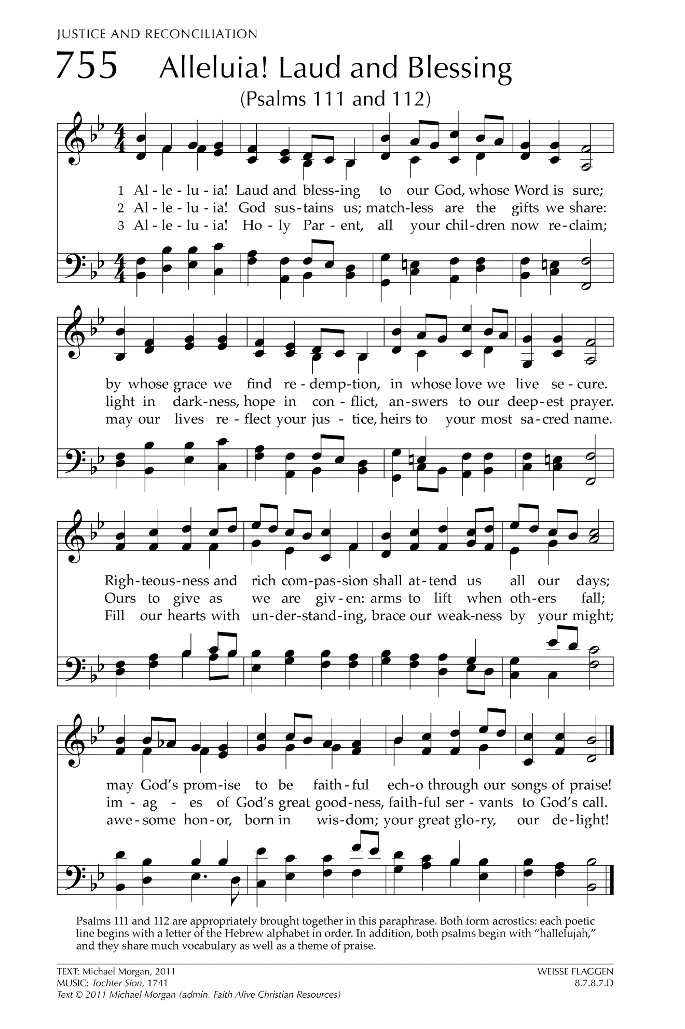

**Let There Be Peace on Earth**

Let there be peace on earth  
And let it begin with me  
Let there be peace on earth  
The peace that was meant to be

With God as our Father  
Christians all are we  
Let us walk with each other  
In perfect harmony.

Let peace begin with me  
Let this be the moment now.

With every step I take  
Let this be my solemn vow  
To take each moment and live  
Each moment in peace eternally  
Let there be Peace on Earth  
And let it begin with me!